Paper Template for SST 2022 – Canberra, ACT, Australia
XXX
XXX
XXX

Abstract
This is the layout specification and template definition for the SST2022 Conference, which will be held in Canberra, ACT, Australia 13-16 December. The format is a modification of the one used for IEEE ICASSP conferences. The total length of the abstract is limited to 100 words. The abstract included in your paper and the one you entered during web-based submission must be identical. Avoid non-ASCII characters or symbols in this abstract, as they may not display correctly in the abstract book. You must include index terms as shown below. A maximum of two lines of index terms is allowed.
Index Terms: speech synthesis, unit selection, joint costs

Introduction
This template can be found on the conference website. To ensure compliance with the layout specifications, please use either the Word® or LaTeX format template when preparing your submission. Both templates are available through the conference website:
https://sst2022.com.
Please contact the conference organising committee at sst2022conf@gmail.com with any questions.

Page layout and style
Authors should observe the following rules for page layout. It is recommended that authors use the provided template (Word® or LaTeX) and check details against the corresponding example file.

Basic layout features
- Papers submitted must be formatted for A4 paper.
- A maximum of four pages is allowed for the main content of the paper, but acknowledgements and references can optionally continue onto a 5th page.
- Two columns are used for all text except for the title. The only exceptions allowed are large figures needing to span both columns.
- Left margin is 20 mm.
- Column width is 80 mm.
- The space between columns is 10 mm.
- Top margin is 25 mm, except for the first page, which is 30 mm to the title top.
- Text height (without headers and footers) is at most 235 mm.
- Headers and footers must be left empty (they will be added for printing and the SST2022 media).
- All paragraphs should have first-line indentation of 5mm, except for the first paragraph after every section break, which should have no indentation.

Title section
In the title section for the initial round of submissions, please ensure anonymity by replacing the authors’ names, affiliations, and email addresses with “XXX.” The title should remain as intended.
In the revised submission, authors’ details should be added. If a paper has multiple authors, all authors’ names should be followed by a superscript numeral, while the respective affiliations should be preceded by the corresponding superscript numeral.

Headings
Section headings are to be centered in boldface with the first word capitalized and the rest of the heading in lower case, except proper nouns. Sub-section headings are in boldface font and are left aligned within the column. Sub-sub-section headings are in italics and are left aligned within the column. No more than 3 levels of headings may be used.

Text font
Times or Times Roman font must be used for the paper, as in this template. Font size of the main text must be 9 points, and 8 points in the References section. Title text must be 14 point boldface. Authors’ names should be 12 points italics, and affiliations should be 12 points regular. Email addresses should be 9 points Courier. Section headers should be 12 points, while sub-section and sub-sub-section headers should be 9 points. Figure and table caption text should be 9 point italics.
Other font types may be used if required for special purposes. It is VERY IMPORTANT that all special fonts used are embedded in the final PDF!
LaTeX users should use Adobe Type 1 fonts such as Times or Times Roman. These are used automatically by the SST2022.sty style file. Authors must not use Type 3 (bitmap) fonts.

Page numbering
Do not include page numbers! Final page numbers will be added later to the document electronically.

Hyperlinks
For technical reasons, the proceedings editor will strip all active links from the papers during processing. Hyperlinks can be included in your paper, if written in full, e.g. "http://www.foo.com/index.html". The link text must be all black, with no special formatting.

Tables and figures
Figure 1: Large figures spanning both columns may be used sparingly.
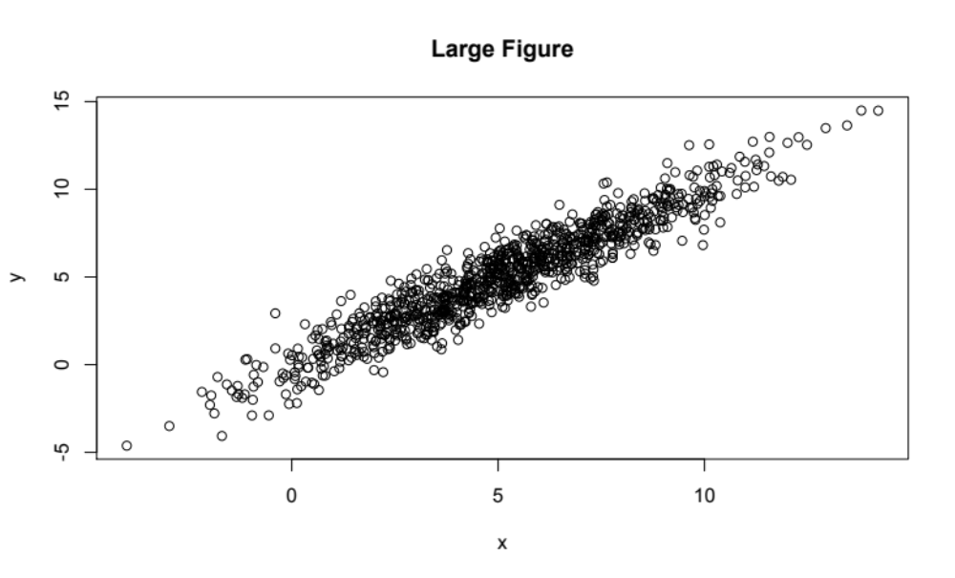
All tables and figures should be centered in their respective columns, or with respect to the page when spanning both columns. Every table and figure must include a descriptive caption. Figures spanning both columns must be located at either the top or the bottom of the page.
Tables and figures should be numbered sequentially within type. E.g., Table 1 should precede Table 2, but Figure 1 may be located anywhere in the paper with respect to either Tables 1 or 2.

Tables
Figure 2: An example of a figure.
An example of a table is shown in Table 1. The caption text may be above or below the table.
Table 1. Figure and table captions in italics.
Ratio | Decibels
1/1 | 0
2/1 | ≈ 6
3.16 | 10
1/10 | 20
10/1 | -20
100/1 | 40
1000/1 | 60

Figures
Figure captions should follow each figure and have the format given in Figure 2. Figures should be preferably line drawings. If they contain gray levels or colors, they should be checked to print well on a high-quality non-color laser printer.
Graphics (i.e., illustrations, figures) should not use stipple fill patterns, as they will not reproduce properly in Acrobat PDF. For best reproducibility, please use only SOLID FILL COLORS.

Equations
Equations should be placed on separate lines and numbered. Examples of equations are given below. Specifically,
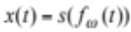, (1)
where 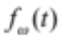 is a special warping function
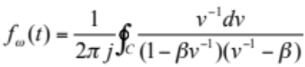. (2)
A residue theorem states that
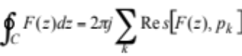, (3)
Applying (3) to (1), it is quite straightforward to see that
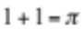. (4)
Finally, we have proven the secret theorem of all speech sciences. No more math is needed to show how useful the result is!

References
References should be formatted according to the IEEE standards. In the references section, papers should should be numbered in order of appearance rather than alphabetically by authors’ last names, for example [1], [2], [3], [4], and [5].

Anonymity
The review process for SST2022 will be anonymous. As such, the names of the authors and affiliations should not be mentioned in either the title or the text of the paper during the initial round of submissions. Furthermore, any references to the authors’ previous research should be made as anonymous as possible. For instance, instead of “In our previous study [2], we show that…” use “As shown previously in [2]….” Work that the authors have submitted for publication but has not yet been published should be referenced as “anonymous,” as in [5].
Please do not include acknowledgements during initial submissions, and please also ensure that no author details appear in the Document Properties of the PDF file.
Authors’ details should be added during revised paper submissions. Additionally, acknowledgements and references to the authors’ previous work may be reintroduced.

Submitted files
Authors are requested to submit PDF files of their manuscripts. The PDF file should comply with the following requirements:
- There must be no password protection on the PDF file.
- All fonts must be embedded.
- The file must be text searchable.
The proceedings editors will contact authors of non-complying files to obtain a replacement. In order not to endanger the preparation of the proceedings, papers for which a timely replacement is not provided will be withdrawn.

Page length
Submitted papers are to be four pages long, with an optional 5th page for acknowledgements and references only. Papers under or over four pages of content and five total pages may not be considered. What follows in the rest of this section is filler text. Please continue reading to the end of the document.
Page filler page filler page filler page, filler page filler page filler page filler, page filler. Page filler page filler page filler page filler page, filler page filler page filler. Page filler – page filler page filler page filler page!
Filler page filler page filler page filler page filler page filler page filler page filler page filler. Page filler page filler page filler page filler; page filler page, filler page, filler page filler page filler page.
Filler page filler page filler page filler page filler page filler page filler page filler page filler. Page filler page filler page filler page filler; page filler page, filler page, filler page filler page filler page. Filler page filler page, filler page filler page filler page filler page filler. Page filler page filler page filler page filler page filler page filler page filler page filler page filler page filler, page filler. Page filler page filler page filler page filler page filler page filler page filler page filler page filler page filler page filler.
Filler page filler page filler page filler page filler page filler page filler page filler page filler. Page filler page filler page filler page filler; page filler page, filler page, filler page filler page filler page. Filler page filler page, filler page filler page filler page filler page filler. Page filler page filler page filler page filler page filler page filler page filler page filler page filler page filler, page filler. Page filler page filler page filler page filler page filler page filler page filler page filler page filler page filler page filler.
Filler page filler page filler page filler page filler page filler page filler page filler page filler. Page filler page filler page filler page filler; page filler page, filler page, filler page filler page filler page. Filler page filler page, filler page filler page filler page filler page filler. Page filler page filler page filler page filler page filler page filler page filler page filler page filler page filler, page filler. Page filler page filler page filler page filler page filler page filler page filler page filler page filler page filler page filler.
Filler page filler page filler page filler page filler page filler page filler page filler page filler. Page filler page filler page filler page filler; page filler page, filler page, filler page filler page filler page. Filler page filler page, filler page filler page filler page filler page filler. Page filler page filler page filler page filler page filler page filler page filler page filler page filler page filler, page filler. Page filler page filler page filler page filler page filler page filler page filler page filler page filler page filler page filler.
Filler page filler page filler page filler page filler page filler page filler page filler page filler. Page filler page filler page filler page filler; page filler page, filler page, filler page filler page filler page. Filler page filler page, filler page filler page filler page filler page filler. Page filler page filler page filler page filler page filler page filler page filler page filler page filler page filler, page filler. Page filler page filler page filler page filler page filler page filler page filler page filler page filler page filler page filler.
Filler page filler page filler page filler page filler page filler page filler page filler page filler. Page filler page filler page filler page filler; page filler page, filler page, filler page filler page filler page. Filler page filler page, filler page filler page filler page filler page filler. Page filler page filler page filler page filler page filler page filler page filler page filler page filler page filler, page filler. Page filler page filler page filler page filler page filler page filler page filler page filler page filler page filler page filler.
Filler page filler page filler page filler page filler page filler page filler page filler page filler. Page filler page filler page filler page filler; page filler page, filler page, filler page filler page filler page. Filler page filler page, filler page filler page filler page filler page filler. Page filler page filler page filler page filler page filler page filler page filler page filler page filler page filler, page filler. Page filler page filler page filler page filler page filler page filler page filler page filler page filler page filler page filler.
Filler page filler page filler page filler page filler page filler page filler page filler page filler. Page filler page filler page filler page filler; page filler page, filler page, filler page filler page filler page. Filler page filler page, filler page filler page filler page filler page filler. Page filler page filler page filler page filler page filler page filler page filler page filler page filler page filler, page filler. Page filler page filler page filler page filler page filler page filler page filler page filler page filler page filler page filler.
Filler page filler page filler page filler page filler page filler page filler page filler page filler. Page filler page filler page filler page filler; page filler page, filler page, filler page filler page filler page. Filler page filler page, filler page filler page filler page filler page filler. Page filler page filler page filler page filler page filler page filler page filler page filler page filler page filler, page filler. Page filler page filler page filler page filler page filler page filler page filler page filler page filler page filler page filler.
Filler page filler page filler page filler page filler page filler page filler page filler page filler. Page filler page filler page filler page filler; page filler page, filler page, filler page filler page filler page. Filler page filler page, filler page filler page filler page filler page filler. Page filler page filler page filler page filler page filler page filler page filler page filler page filler page filler, page filler. Page filler page filler page filler page filler page filler page filler page filler page filler page filler page filler page filler.
Filler page filler page filler page filler page filler page filler page filler page filler page filler. Page filler page filler page filler page filler; page filler page, filler page, filler page filler page filler page. Filler page filler page, filler page filler page filler page filler page filler. Page filler page filler page filler page filler page filler page filler page filler page filler page filler page filler, page filler. Page filler page filler page filler page filler page filler page filler page filler page filler page filler page filler page filler.
Filler page filler page filler page filler page filler page filler page filler page filler page filler. Page filler page filler page filler page filler; page filler page, filler page, filler page filler page filler page. Filler page filler page, filler page filler page filler page filler page filler. Page filler page filler page filler page filler page filler page filler page filler page filler page filler page filler, page filler. Page filler page filler page filler page filler page filler page filler page filler page filler page filler page filler page filler.
Filler page filler page filler page filler page filler page filler page filler page filler page filler. Page filler page filler page filler page filler; page filler page, filler page, filler page filler page filler page. Filler page filler page, filler page filler page filler page filler page filler. Page filler page filler page filler page filler page filler page filler page filler page filler page filler page filler, page filler. Page filler page filler page filler page filler page filler page filler page filler page filler page filler page filler page filler.
Filler page filler page filler page filler page filler page filler page filler page filler page filler. Page filler page filler page filler page filler; page filler page, filler page, filler page filler page filler page. Filler page filler page, filler page filler page filler page filler page filler. Page filler page filler page filler page filler page filler page filler page filler page filler page filler page filler, page filler. Page filler page filler page filler page filler page filler page filler page filler page filler page filler page filler page filler.
Filler page filler page filler page filler page filler page filler page filler page filler page filler. Page filler page filler page filler page filler; page filler page, filler page, filler page filler page filler page. Filler page filler page, filler page filler page filler page filler page filler. Page filler page filler page filler page filler page filler page filler page filler page filler page filler page filler, page filler. Page filler page filler page filler page filler page filler page filler page filler page filler page filler page filler page filler.
Filler page filler page filler page filler page filler page filler page filler page filler page filler. Page filler page filler page filler page filler; page filler page, filler page, filler page filler page filler page. Filler page filler page, filler page filler page filler page filler page filler. Page filler page filler page filler page filler page filler page filler page filler page filler page filler page filler, page filler. Page filler page filler page filler page filler page filler page filler page filler page filler page filler page filler page filler.
Filler page filler page filler page filler page filler page filler page filler page filler page filler. Page filler page filler page filler page filler; page filler page, filler page, filler page filler page filler page. Filler page filler page, filler page filler page filler page filler page filler. Page filler page filler page filler page filler page filler page filler page filler page filler page filler page filler, page filler. Page filler page filler page filler page filler page filler page filler page filler page filler page filler page filler page filler.
Filler page filler page filler page filler page filler page filler page filler page filler page filler. Page filler page filler page filler page filler; page filler page, filler page, filler page filler page filler page. Filler page filler page, filler page filler page filler page filler page filler. Page filler page filler page filler page filler page filler page filler page filler page filler page filler page filler, page filler. Page filler page filler page filler page filler page filler page filler page filler page filler page filler page filler page filler.
Filler page filler page filler page filler page filler page filler page filler page filler page filler. Page filler page filler page filler page filler; page filler page, filler page, filler page filler page filler page. Filler page filler page, filler page filler page filler page filler page filler. Page filler page filler page filler page filler page filler page filler page filler page filler page filler page filler, page filler. Page filler page filler page filler page filler page filler page filler page filler page filler page filler page filler page filler.
Filler page filler page filler page filler page filler page filler page filler page filler page filler. Page filler page filler page filler page filler; page filler page, filler page, filler page filler page filler page. Filler page filler page, filler page filler page filler page filler page filler. Page filler page filler page filler page filler page filler page filler page filler page filler page filler page filler, page filler. Page filler page filler page filler page filler page filler page filler page filler page filler page filler page filler page filler.
Filler page filler page filler page filler page filler page filler page filler page filler page filler. Page filler page filler page filler page filler; page filler page, filler page, filler page filler page filler page. Filler page filler page, filler page filler page filler page filler page filler. Page filler page filler page filler page filler page filler page filler page filler page filler page filler page filler, page filler.

Conclusions
Authors should not rely on proofreading only their Word/LaTeX files. Authors must proof read their PDF file prior to submission of the PDF, to ensure all content and formatting is correct.

Acknowledgements
Acknowledgements are not allowed during the initial round of submissions. Acknowledgements may be reintroduced during revised paper submissions, and they should go here.

References
- Smith, J. O. and Abel, J. S., “Bark and ERB Bilinear Transforms”, IEEE Trans. Speech and Audio Proc., 7(6):697-708, 1999.
- Soquet, A., Saerens, M. and Jospa, P., “Acoustic-articulatory inversion”, in T. Kohonen [Ed], Artificial Neural Networks, 371-376, Elsevier, 1991.
- Stone, H.S., “On the uniqueness of the convolution theorem for the Fourier transform”, NEC Labs. Amer. Princeton, NJ. Online: http://citeseer.ist.psu.edu/176038.html, accessed on 19 Mar 2008.
- Fant, G., Acoustic Theory of Speech Production, Mouton, 1960.
- Anonymous, “Some study that has not yet been published”, submitted.

